**SKILLS REQUIRED FOR COMPUTER SCIENCE AND INDUSTRY**

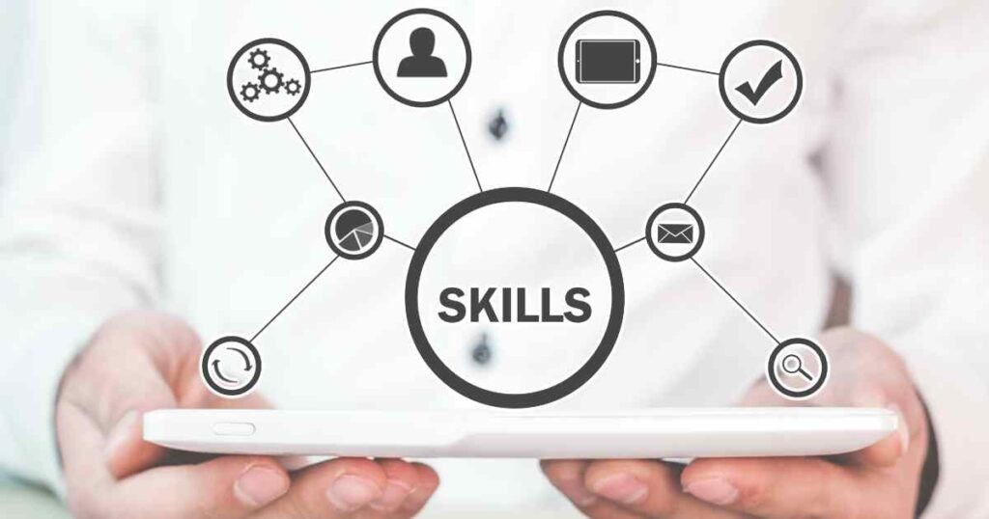

**SUBJECT NAME: TECHNOLOGY AND INFORMATION SYSTEM**

**SUBJECT CODE: SECP 1513**

**SEMESTER: SEMESTER 1**

**GROUP MEMBERS:**

**1.SYAZWINA MARSYA BINTI SHAHRIZAN (A24CS0196)**

**2.SITI MAISARAH BINTI AHMAD ARZMY (A24CS0190)**

**3.RUJITHRAA NAIR (A24CS0181)**

**4.OSAMA HAMOOD (A22EC4025)**

**5.MOMEN ELGASIM MOHAMED (A24CS0021)**

**Speaker’s Experience**

Mr. Mohd Hakimi Iqmall, a UTM alumnus and UTM Digital professional, shared his career journey and key skills for success in computer science. He introduced UTM Digital and highlighted his experience at ME-Tech Solution SDN BHD and Okakichi Sdn Bhd as a game programmer and animator before joining UTM Digital in 2021. In UTM, he developed systems like Payroll 2.0, the SSPA System, and the Integrity System, demonstrating technical expertise and leadership.

He emphasized essential technical skills, including database structures, debugging, version control, programming languages, system frameworks, and security awareness, as well as logical and analytical problem-solving. He also stressed soft skills like communication, teamwork, leadership, and adherence to SDLC methodologies, along with testing, documentation, and problem-solving for professional success.

Mr. Hakimi urged students to build strong programming skills during their studies while developing soft skills to collaborate and lead effectively, ensuring success in the ever-evolving field of computer science.

Mr. Nik Mohd Habibullah, a UTM alumnus and entrepreneur, shared his journey, including his internship at UTM and designing a montage during his third year. He later ventured into entrepreneurship, founding businesses such as Micro Semiconductor Sdn Bhd, GetMe Hired, and Dialysis Manager.

He introduced the IRPA method (Identify, Research, Prepare, Apply) for approaching job applications. Mr. Nik emphasized aligning job applications with one’s educational background and skills, understanding personal strengths and weaknesses, and conducting thorough research on the company’s market sustainability, industry competitiveness, and financial stability. He also highlighted the importance of an authentic resume that reflects strengths and career objectives, rather than just focusing on its appearance.

For entrepreneurship, Mr. Nik explained how to apply the IRPA method, noting that while it follows a similar approach, the risks are higher than in job hunting. He advised identifying a service or product, evaluating the market size and sustainability, and exploring the technologies that can be incorporated to ensure business success.

**Skills Required For Computer Science**

Mr. Mohd Hakimi Iqmall emphasized essential skills for computer science, including both technical and project management abilities. Key technical skills mentioned include proficiency in programming languages such as C, C++, C#, Python, Java, and PHP, which are widely used in the field. Students must continuously evolve their programming skills as technology advances. He also stressed the importance of understanding database structures, as this knowledge will be crucial for future milestones. “Information is both qualitative and quantitative, and that students and managers must understand how to interpret and integrate both types of information in decision-making" mentioned by Freeman and Rowley, 1995.Additionally, debugging systems were highlighted as an essential skill, as issues inevitably arise in the field. Development tools like Visual Studio and VSCode were noted for their significant role in helping developers manage and streamline their work.As for management skills, problem-solving and communication skills were emphasized as vital to ensure the needs of the system are exactly fulfilled to customer desires.

**Skills Required By The Industry**

Success in computer science requires a solid foundation in coding, databases, and algorithm design, using techniques like divide-and-conquer and dynamic programming for efficiency. Networking and cybersecurity, including ethical hacking and encryption, ensure secure data flow. Reliable software development depends on testing methods like unit and performance testing, while cloud computing expertise in platforms like AWS and Azure is increasingly vital.Soft skills are equally important. Effective collaboration requires managing diverse perspectives, and adaptability is key to keeping pace with rapidly evolving technology. Time management and leadership help balance responsibilities and guide teams. Analytical skills, critical thinking, and research enable problem-solving and uncovering insights.Bridging academia and industry demands continuous learning, algorithmic thinking, cloud expertise, and collaboration key to driving innovation and solving real-world challenges.

**Reflection**

I plan to focus on developing strong technical skills in programming, data structures, and algorithms during my first two years at UTM. I will work on practical projects, showcase them on GitHub, and participate in hackathons and workshops to network and gain exposure. To improve my teamwork and communication, I will engage in group projects and extracurricular activities.(Marsya)

I aim to address my weaknesses and improve them to make better career choices. Through research, I will understand the computer science industry, company stability, and their impact on my success. I will recognize the importance of a resume in presenting my strengths, and I plan to pursue more activities to showcase my dedication to future employers.(Rujithraa)

I believe success requires continuous self-improvement, practical experience, and focus. I will master programming languages and apply them to university projects while building a professional network through GitHub. Staying engaged with the community will improve my communication and adaptability. I will prepare for technical interviews, build a personal brand, and learn from setbacks.(Maisarah)

Success in computer science requires more than technical skills it demands adaptability, communication, and leadership. Challenges like learning frameworks under tight deadlines have strengthened my resilience. By bridging academic knowledge with industry needs, I’m driven to learn, innovate, and create something impactful in this ever-evolving field.(Momen)

Balancing technical expertise and soft skills is essential, as Mr. Hakimi emphasized foundational skills like programming and debugging, and Mr. Nik stressed understanding personal strengths and market dynamics. I plan to focus on both technical and interpersonal skills through practical projects, workshops, and staying updated on emerging trends like AI and blockchain.(Osama)

**Reference**

1. How to write in an academic style. (n.d.). The University of Sheffield. <https://www.sheffield.ac.uk/study-skills/writing/academic/style>
2. Home. (n.d.). Academic Phrasebank. https://www.phrasebank.manchester.ac.uk/